Nutrition

**What you need to know:**

* Identify the seven classes of food as: carbohydrates, fats, proteins, vitamins, minerals, fibre and water and highlight types of food that fall into these categories
* Identify the exercise related function of each of these types of food
* Describe a balanced diet and the energy balance of food and be able to relate this to your own practical activity.
* Identify the difference in diet composition between endurance athletes and power athletes
* Identify the percentage body fat/body composition and Body Mass Index (BMI) as measures of nutritional suitability.
* Give a definition of obesity and understand the limitations in trying to define it

Nutrition and diet can contribute to a successful performance. A balanced diet is essential for optimum performance in all sporting activities. What you can eat can have an affect on your health, your weight and your energy levels! Top performers place huge demands on their bodies during both training and competition. Their diet must meet those energy requirements as well as provide nutrients for tissue growth and repair. There are six groups of nutrients that should be present in all sports performers:

# Carbohydrates

There are two types of carbohydrates.

***Simple*** *carbohydrates*: - found in fruits and are easily digested by the body. They are also often found in processed foods and anything with refined sugar added.

***Complex*** *carbohydrates*: - found in nearly all plant-based foods, and usually take longer for the body to digest. They are most commonly found in bread, pasta, rice, and vegetables.

Carbohydrates play an important role in the performance of exercise lasting an hour or more. They are the main fuel for high intensity or anaerobic work. Therefore it is imperative that carbohydrate is consumed before, during and after exercise. Carbohydrates are now not just simply thought to provide fuel for muscles. It is now important to consider the ‘glycaemic index’ and release rate of different carbohydrates and the consequence this has on ***when*** they should be consumed in relation to training. Foods with a lower glycaemic index, such as fruit cause a slower, sustained release of glucose to the blood, wheras as foods with a high glycaemic index such as bread and potatoes cause a rapid, short rise in blood glucose. Suitable foods to eat 3-4 hours before exercise include beans on toast, pasta or rice with a vegetable based sauce, breakfast cereal with milk, crumpets with jam or honey. Suitable snacks to eat 1-2 hours before exercise include fruit smoothies, cereal bars, fruit flavoured yoghurt and fruit. Wheras one hour before exercise, liquid consumption appears more important through sports drinks and cordials.

## Carbohydrates

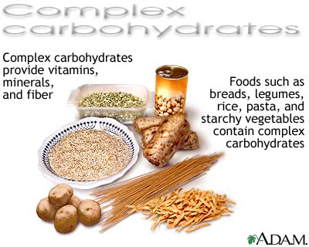

**Key term:** glycaemic index - this ranks carbohydrates according to their effect on our blood glucose levels.

**Fats**

Fats are the secondary energy fuel for low intensity, aerobic work such as jogging. Fats are made from glycerol and **fatty acids**. Each glycerol is attached to three fatty acids. Glycerol and fatty acids contain the elements carbon, hydrogen, and oxygen. Fats contain a lot of carbon. This is why they give us so much energy. Fat is an important energy fuel during low intensity exercise. It is also a carrier for fat soluble vitamins A D E and K. However, too much fat can lead to excessive weight which will affect levels of stamina and limit flexibility.



# Proteins

These are a combination of many chemicals called amino acids and are important for tissue growth and repair and to make enzymes, hormones and haemoglobin. Generally proteins tend to provide energy when glycogen and fat stores are low. However, during strenuous activities or sustained periods of exercise proteins in the muscles may start to be broken down to provide energy.

## Protein

**10-15%**

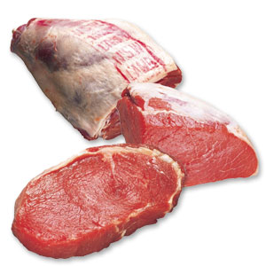

[cheese_cheddar](http://images.google.co.uk/imgres?imgurl=http://www.hormel.com/images/glossary/c/cheese_cheddar.jpg&imgrefurl=http://www.hormel.com/kitchen/glossary.asp?id=33142&catitemid=&h=150&w=252&sz=5&tbnid=D6aPfCcXkhQJ:&tbnh=63&tbnw=106&hl=en&sta)

# Vitamins

Vitamins are needed for muscle and nerve functioning, tissue growth and the release of energy from foods. Excessive consumption will not have any beneficial effects as vitamins cannot be stored in the body so additional amounts will be excreted through urine.

**Minerals**

Minerals assist in bodily functions, calcium, for example is important for strong bones and teeth and iron helps form haemoglobin which will enhance the transport of oxygen and therefore improve stamina levels. Minerals tend to be dissolved by the body as ions and are called electrolytes. Two of the functions they have are to facilitate the transmission of the nerve impulses and enable effective muscle contraction, both of which are important during exercise. It is important to get the right balance. Too much sodium (contained in salt) can result in high blood pressure. As with vitamins, excessive consumption is unlikely to enhance performance.

**Fibre**

Good sources of fibre are wholemeal bread and pasta, potatoes, nuts, seeds, fruit, vegetables and pulses. Fibre is important during exercise as it can slow down the time it takes the body to break down food which results in a slower, more sustained release of energy.

# Water

Water constitutes up to 60% of a persons body weight and is essential for good health. It carries nutrients to cells in the body and then removes waste products. It also helps to control body temperature. When an athlete starts to exercise their production of water increases (water is a bi-product of the aerobic system). We also lose a lot of water through sweat. The volume of water we lose depends on the external temperature, the intensity and duration of the exercise and the volume of water consumed before, during and after exercise. Water is important to maintain optimal performance. Make sure you take on fluids regularly. Sports drinks such as lucozade sport and gatorade can boost glucose levels before competition while water will re-hydrate during competition.

**A Balanced Diet**

This diet should contain 15% protein, 30% fat and 55% carbohydrate. During exercise this percentage needs to change in favour of carbohydrates. Sports nutritionists recommend the following:

Proteins10-15%

Fats: 20-25%

Carbohydrates 60-75%

**Energy balance of food**

When we take part in physical activity, the body requires energy and the amount of energy we need is dependent on the duration and type of activity. Energy is measured in calories and is obtained from the body stores or the food we eat. A calorie (cal) is the amount of heat energy required to raise the temperature of 1g of water 1°C. A kilocalorie (kcal) is the amount of heat required to raise the temperature of 1000g of water 1°C.

Most nutritionists state that the basic energy requirements of the average individual are1.3 kcal per hour for every kg of body weight. Therefore if you weigh 60kg you would require:

1.3 x 24 (hours in a day) x 60

= 1872 kcal/day)

This energy requirement increases during exercise up to 8.5 kcal per hour for each Kg of body weight. Therefore in a one hour training session the performer would require an extra 8.5 x 1 x 60kg = 510kcal

From these calculations it is possible to calculate the energy requirements of this performer by adding their basic energy requirements (1872Kcal) to the extra energy needed for that one hour training session (510Kcal)

1872 + 510 = 2382

# What should you eat before a competition?

In order to achieve optimal performance in sport it is essential to be well-fuelled and well-hydrated. This means the importance of a pre-competition meal should not be understated. It should be eaten about 3-4 hours before competing as the food consumed needs to be digested and absorbed in order to be useful. The meal needs to be high in carbohydrate, low in fat and moderate in fibre in order to aid digestion (foods high in fat, protein and fibre tend to take longer to digest). High levels of carbohydrate will keep the blood glucose levels high throughout the duration of the competition/performance. Suggestions for pre-competition meals can be seen in the box below:

**Food:**

* Chicken breast without skin (preferably poached)
* Vegetable based sauce served on the side rather than over the dish
* Two carbohydrate sources such as brown rice or wholemeal pasta
* Unglazed vegetables
* Salad, without a dressing
* Selection of fresh fruit (lots of bananas)
* Fresh fruit salad and yoghurt
* Scrambled eggs, bacon, baked beans and fresh wholemeal toast
* Porridge, special K, muesli

# Drinks

* still water, orange and apple juice

**Tasks to tackle:** Complete the table below with suggestions for a diet for an 18 year old long distance runner weighing 60kg who trains 5 sessions per wk each lasting 2 hours.

|  |  |
| --- | --- |
| Energy requirements without exercise (per week) |  |
| Energy requirements including exercise (per week) |  |
| % carbohydrates |  |
| % fats |  |
| % proteins |  |
| Suggested meals |  |

**Diet composition of an endurance athlete v power athlete**

The body's preferred fuel for any endurance sport is muscle glycogen. If muscle glycogen breakdown exceeds its replacement then glycogen stores become depleted. This results in fatigue and the inability to maintain the duration and intensity of training. In order to replenish and maintain glycogen stores, an endurance athlete needs a diet rich in carbohydrates. Most research seems to suggest that endurance athletes need to consume at least 6 to 10 grams of carbohydrate per kilogram of their body weight. Another key nutrient that is a must is water to avoid dehydration.

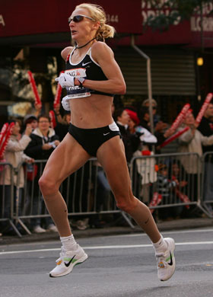Some endurance athletes manipulate their diet to maximise aerobic energy production. One method is **glycogen loading** (often called carbo-loading). Six days before an important competition a performer eats a diet high in protein and fats for three days and exercises at relatively high intensity to burn off any existing carbohydrate stores. This is followed by three days of a diet high in carbohydrates and some light training. The theory is that by totally depleting glycogen stores they can then be increased by up to two times the original amount.

In general endurance athletes require more carbohydrates

than power athletes simply because they exercise for longer periods of time and need more energy.

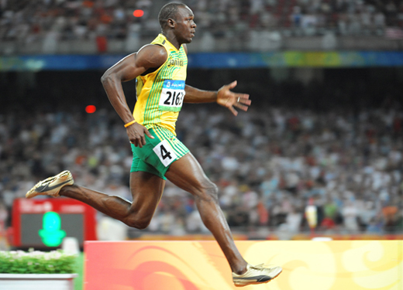

Proteins are very important for power athletes. Not getting enough protein will lead to muscle breakdown. Proteins are important for tissue growth and repair.

**Body fat composition**

This is the physiological make-up of an individual in terms of the distribution of lean body mass and body fat. On average men have less body fat than women, 15% as oppose to 25% approximately. Obviously body composition has an important role in sport. Excess body fat can lead to health problems such as cardiovascular disease and any exercise will require greater energy expenditure as more weight has to be moved around. It is generally agreed that the less body fat the better the performance, but there are some sports with specific requirements for larger amounts of fat such as the defensive linesman in American football or if we take it to the extreme a sumo wrestler!

In most team games, for example, excess body fat would affect the performers’ ability to move freely around the court/field and would increase the onset of fatigue during the game.

**Body mass index (BMI)**

Body mass index or (BMI) takes into account body composition. To calculate your BMIdivide your weight in kilograms by your height in metres squared. A 17 year old, for example, who weighs 75 kg and is 1.80m can calculate their BMI as follows:

BMI = weight (kg)

height(m) x height (m)

BMI = 75 =23.15 1.81 x 1.81

|  |  |  |
| --- | --- | --- |
| BMI | Classification | |
| <19 | Underweight | |
| 19-25 | Normal | |
| 26-30 | Overweight | |
| 30-40 | Obese | |
| >40 | | Morbidly obese |

BMI values vary according to which book you read but the table below is representative of most literature:

**Obesity and limitations of definition**

Definitions of obesity vary from one text book to another. In general, obesity is when there is an excess proportion of total body fat usually due to energy intake being greater than energy output! Obesity carries an increased risk of heart disease, hypertension, high blood cholesterol, strokes and diabetes. It can also increase stress on joints and limit flexibility, as well as the psychological problems of dealing with being obese (a problem even more apparent with size 0 culture)! It occurs when an individual’s body weight is 20% or more above normal weight or when a male accumulates 25% and a female 35% total body fat. The body mass index or BMI is also a common measure of obesity. This takes into account body composition. An individual is considered obese when his or her BMI is over 30.

**Practice makes perfect:**

1. Eating a diet with sufficient calcium and iron would have physiological benefits for an athlete. State the importance of these two minerals for the athlete [3]

1. In what ways should the diet of a long distance runner be different from that of a weight lifter. Give reasons for your answer. [3]

3. A balanced diet for most games players is approximately 60% carbohydrate, 20% fat and 15% protein. Describe the role of each of these food types in maintaining a balanced diet for the games player [3]